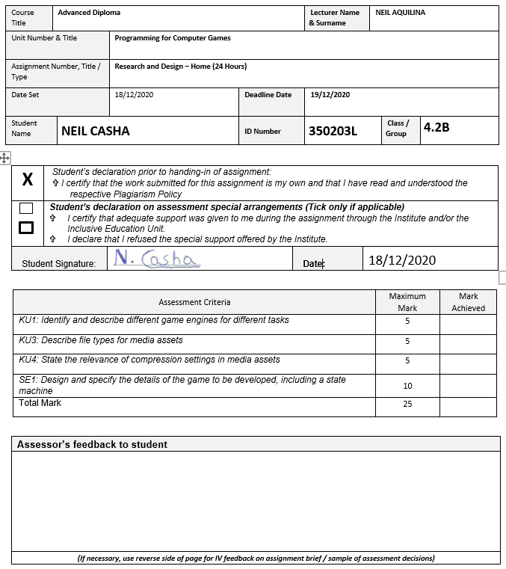

**PCG Research & Design**

**Task 1 - Game Engines**

**Unity**

The Unity game engine uses the **C++** and **C#** programming languages; **Hearthstone** is a game which was made with this game engine. Unity is both a **2D** and **3D** game engine.

**Frostbite**

Frostbite uses **C++** and **C#** programming languages; the **Need for Speed** was created using Frostbite. The engine supports both **2D** and **3D** imaging.

**DUNIA**

This engine uses **C++**. **Far Cry 5** was one of the games created with **DUNIA**. This game engine only supports **3D**.

**Source**

This engine uses the **C++** language; **Half-life 2: Lost Coast** was made with Source. This game engine also only supports **3D.**

**RE Engine**

AnvilNext uses **C++** and **C#**. This engine was used to build **Tom Clancy’s Rainbow Six Siege.** It also only supports **3D.**

**Task 2 - File types for media assets**

**2A**

**SVG –** stands for Scalable Vector Graphics; it is a vector image format which supports 2D graphics and it is an open standard developed by the World Wide Web Consortium. SVG images and their behaviours are defined in XML files.

**WEBP –** is a modern file format which provide both lossless and lossy compressions. It is used for images on the internet. Using this file format, webmasters and developers can create richer images which can make internet applications faster because of their small size. Images of WEBP which are lossless, are known to be 26% smaller than the PNG file format.

**BMP –** also known as the bitmap file format, provide raster graphics and is not dependant on a device. It can store two-dimensional digital images both monochrome and colour. This format supports Various Colour Depths, alpha channels, colour profiles, and optional data compression.

**2B**

**WAV -** Waveform Audio File Format is an audio file format standard, developed by IBM and Microsoft, for storing an audio bitstream on PCs. It is the main format used on Microsoft Windows systems for raw and typically uncompressed audio.

**WMA** - The WMA format is a lossy audio file — like MP3. The file format is an acronym for Windows Media Audio and was first released in 1999 by the Microsoft company for use with their Windows Media Player program in their Windows operating system. The file extension has evolved since its initial launch but has continually retained the WMA file extension.

**Task 3 - Compression in multimedia**

**A**

As most people know, image file compression is done to reduce the size which the image file takes from whatever location is placed. This can be done to an extent to which the quality of the image is still acceptable. This can be important depending on the location where the file is saved. If the storage location has very limited space available, this is where file compression can make a big difference. On the other hand, however, if the image files are being used for a different scenario, such as being embedded in a website or web application, file compression is much more important, because of the file size is rather large, the image may load slower than website, which depending on its structure, may appear very different than intended.

**B**

The goal in audio compression is to reduce the number of bits required to accurately reproduce an analogue sound. Audio file compression can be explained in 2 parts lossy compression and lossless compression.

In technical terms, the audio data, which is recorded in waveform, is reduced to differing extents for transmission respectively, which may cause in loss or no loss of data.

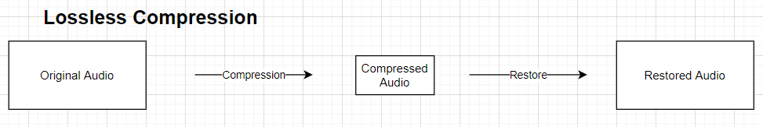For **lossless compression**, the size of the digital file is reduced without affecting the sound quality. You get the same quality as the original audio, but it takes up less storage space on a storage location.

Therefore, when restored, the outcome will be the same as the original audio with no loss in quality.

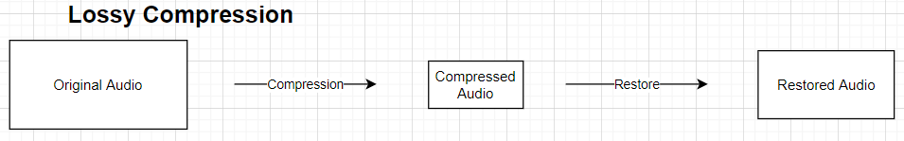For **lossy compression** however, when the audio is compressed, there is already some loss in quality in order to reduce to file size more drastically than lossless compression. Therefore, when trying to restore the audio, the outcome will not be identical to the original file, because the quality lost during compression cannot be retrieved.